**Assignment 2**

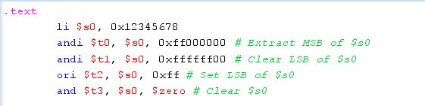

**Assignment 3**

**a)** abs $s0, $s1

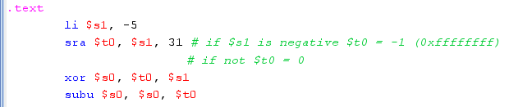

**b)** move $s0, $s1

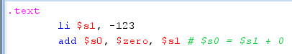

**c)** not $s0



**d)** ble $s1, s2, L

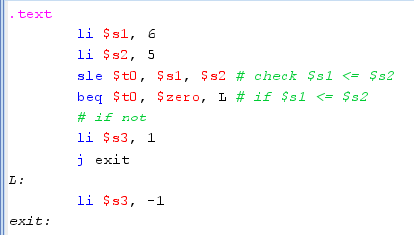

**Assignment 4**

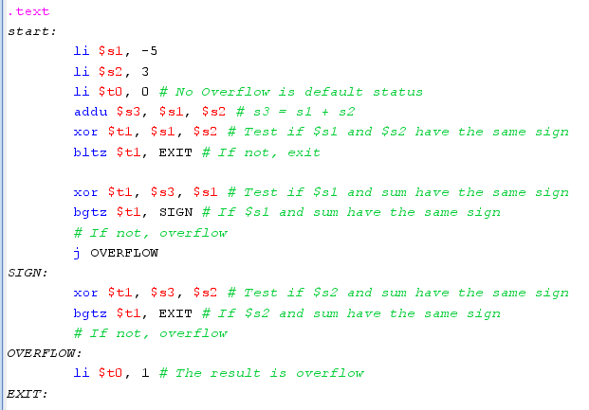

.text

start:

li $s1, -5

li $s2, 3

li $t0, 0 # No Overflow is default status

addu $s3, $s1, $s2 # s3 = s1 + s2

xor $t1, $s1, $s2 # Test if $s1 and $s2 have the same sign

bltz $t1, EXIT # If not, exit

xor $t1, $s3, $s1 # Test if $s1 and sum have the same sign

bgtz $t1, SIGN # If $s1 and sum have the same sign

# If not, overflow

j OVERFLOW

SIGN:

xor $t1, $s3, $s2 # Test if $s2 and sum have the same sign

bgtz $t1, EXIT # If $s2 and sum have the same sign

# If not, overflow

OVERFLOW:

li $t0, 1 # The result is overflow

EXIT:

**Assignment 5**

